**Wireframe document**

**THYROID_DETECTION PROJECT:**

Step1: First thing anyone will see is a pop-up window on Homepage which will ask for User Inputs

To upload a file for getting the predictions.

This is the UI that user sees when he uses the project .

He will uploads the file in which data is present to get predictions.

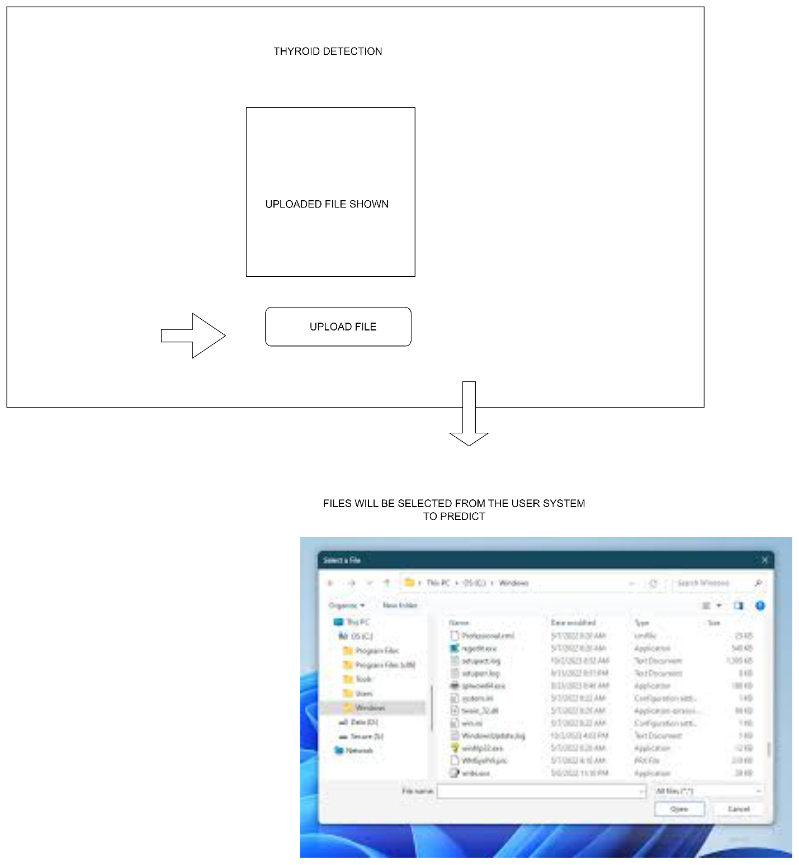

When user clicks on the upload file it will takes to the user system . now he can select the file for which he want the predictions.

It will took some time for predicting

As our project currently running in apprunner it will take model from the s3 bucket and starts prediction.

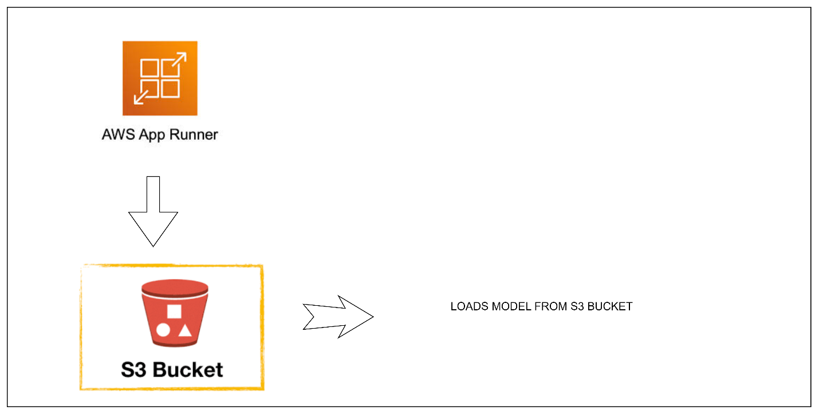

After that prediction has completed then

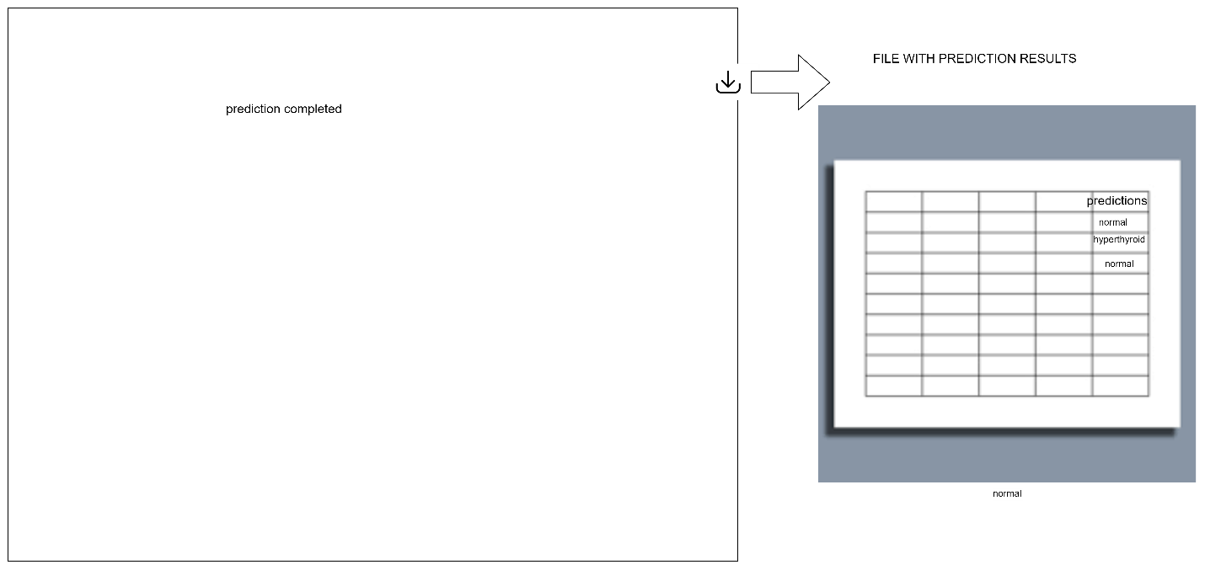

Again the user gets the predictions in the form of a file. The predictions are attached to the user provided file as a column named result.